EXPERIMENT-23
23) Implement the Top hat technique as a Morphological operation to dilate the foreground regions based on Open CV.
a)CODE
import cv2
import numpy as np
import os

path = os.path.join(os.path.expanduser("~"), "Desktop", "photo.jpg")
img = cv2.imread(path, 0)

if img is not None:
kernel = np.ones((5, 5), np.uint8)
result = cv2.morphologyEx(img, cv2.MORPH_TOPHAT, kernel)
cv2.imwrite(os.path.join(os.path.expanduser("~"), "Desktop", "tophat_output.jpg"), result)
print("Output saved on Desktop")
cv2.imshow("Top Hat", result)
cv2.waitKey(0)
cv2.destroyAllWindows()
else:
print("Check photo.jpg name and Desktop location")
print("Expected path:", path)

b) INPUT
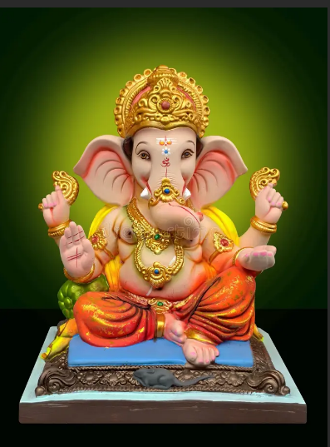

C) OUTPUT
